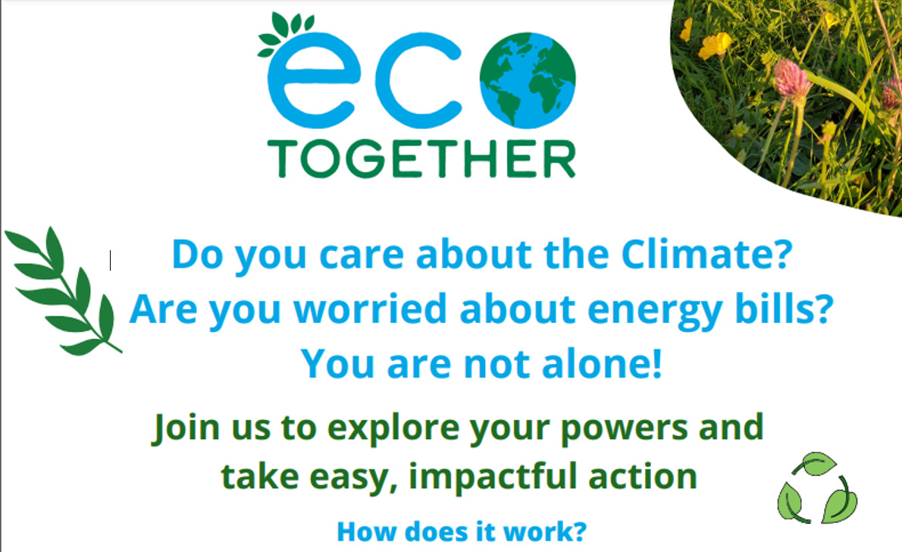

EcoTogether is a programme of six free, simple, structured sessions to explore how YOU can best make a difference, using well-researched materials with a small group of like-minded people.
Edit text in this box For more information on the group in (XYZ street/ area) contact (first name) from (group/street) at (XYZ email) before the (date). You can create a new gmail address if you don’t want to use your personal one. You could also create your own message.
Then print with ‘4 pages per sheet” setting. We suggest you start with 100 flyers and if need be, try another 100. You can also print these in A4 to stick on lamp posts or notice boards. We’re happy to help, just contact us at hello@ecotogether.info

