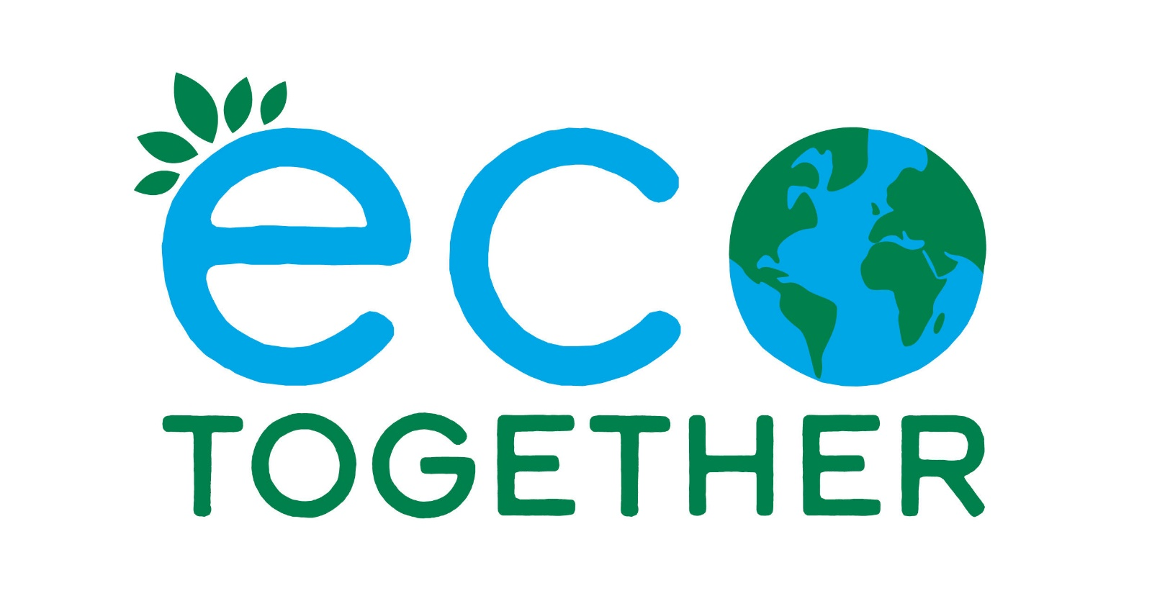

First Host notes

FIRST HOST NOTES
Thanks for your interest in convening an Eco Together group!
The project has been carefully designed to have a light workload and be simple enough for anyone to run.
The first host is deliberately intended to NOT be the “chair” or “leader” of the group, so that the first host can participate in the project. The first host could be described as “convening” – bringing together the group. The first host does have three special roles;
- Getting the group together
- Running the first session
- Feeding back on progress
You can convene a group on your own, or jointly with other people you know.

Getting a group together

Eco Together can be run with any small group of around 4-10 people.
In an ideal world, a couple of people from each Eco Together group would go on to be first host for another group – if they started with neighbours, convening a group of friends or an interest group and vice versa.
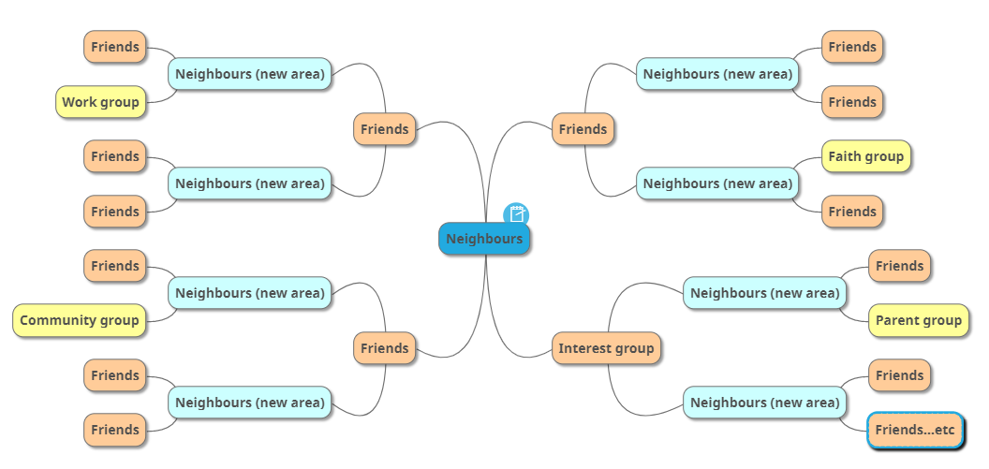
This way, the project would expand organically geographically as in the diagram below. However, people’s lives are fuller than ever. It is brilliant if any participant simply completes the first 5 sessions.

Gathering a group of friends or people from an interest group
This should be straightforward – simply ask them, and find a date for the first session. You may need to chat with them to explain the project first. Feel free to do this from your own knowledge, perhaps using the wording in the next paragraph. Contact hello@ecotogether.info if you’d like support.
Brevity is key in your introduction. The following uses the wording on the first page of the website, and can work as a social media message, or as a verbal introduction. e.g.:
Concerned about the environment?
Eco Together brings together small groups of neighbours, friends or colleagues for 5 structured sessions. The participants support each other in making a difference. Using an Info Pack designed to ​bring tangible results and to help build strong support groups, each person selects their own activities.
Group members run the sessions themselves and there are no costs involved.

There are also some template emails below to make your follow up easier.
Gathering a group of neighbours
It might be very easy to get your neighbours involved if you already know them, you can just ask them if they want to join the group and start with the first session if so.
If you don’t know your neighbours, or need a few more involved, feel free to use the table in appendix 1 to work backwards to a date. Be kind to yourself if you are busy – allow yourself plenty of time

Getting the word out
Templates: See Appendix 2 for templates of flyers, posters, presentation slides and social media. These are very basic and low tech to be easily editable, and you may be able to do far better ones! Feel free to copy and paste the Eco Together logo onto your materials.
Budget: We don’t have much budget for the project, but if printing costs are a barrier, please let us know: hello@ecotogether.info.
Useful tools
- Emailing: If you don’t want to use your personal email address on your promotional material, you can create a new free email account (for example Gmail) to manage correspondence on the project.

- Choosing a date: You could use a simple scheduler site such as Doodle which, whilst it now has a lot of popup ads, gathers people’s date choices and can save a lot of time. Similarly, WhatsApp has this function. A note of caution – people who are less comfortable with computers may need the dates emailed or written to them rather than using Doodle.

Types of promotion
- Posters can be downloaded from the first host page, printed and displayed in windows and waterproof holders around the neighbourhood.

- Leaflets can be posted through your neighbours’ door. We suggest 50-100. If you don’t get enough people, you could try another round. Please keep track of how many flyers you used and how many people got in touch were interested for your feedback to us.

- Digital: Consider a message on a street or local social media group or through a resident’s association.

- Print: To go beyond your own street, consider local magazines or Parish newsletter

- Intro session: You may be able to move straight to the first session if people seem fairly committed. Or if people need more info, you could run an intro session. Contact hello@ecotogether.info if you’d like support with this, or feel free to organise how you see fit.

Running the first session
The person leading does not need any special knowledge. The sessions have been designed to be simple enough to “run themselves” through the Activity Sheet, with just a little input from the leader to keep things moving.

There are a few things you can do to help that first session go smoothly:

- A few days before the session consider reminding people that in order for the session to run more smoothly, there is some really interesting reading and thinking to do, in the Info Pack.

- Make sure people can access the Info Pack and Activity Sheets. People can either print them or view them online, but some may find either a challenge and may not speak up unless asked.

- In each session there is a series of exercises. Give the group a minute or two to think and to note down their response, then take it in turns for each person to speak.
- The Guidelines agreed in the first session should help you – people agree to take it in turns to speak so everyone gets a chance, and to not interrupt or make comment until everyone has done this. The whole group should help with this, but people may need to be reminded – it’s interesting stuff so it’s easy to get off track.

- Consider appointing a timekeeper to help you stick to the schedule.

- Enjoy! You are just helping it to run smoothly, giving everyone their fair chance to speak.

Monitoring and feedback
Your feedback is like gold-dust as we think about the next steps of the project. We don’t want to overload you with paperwork, but we’d be very grateful if you could fill out a and submit it to us at the end. Please be very honest so we can evolve the project. We will circulate the monitoring survey prior to the end of the project.
APPENDIX 1: PROMOTION PLAN
NEIGHBOUR PROMOTION  TIMELINE | How many weeks will it take you? | Date to start | Possible tasks – you choose. Each could take around an evening to complete.
Prepare promotion |  |  | - Edit posters, leaflets  - Get leaflets printed  - Decide which streets you’ll leaflet in the first round and which to leaflet if you don’t get enough (around 100 houses per round)  - Edit social media/ email message  - Contact local resident’s group to see about email message  - Contact community magazine to see about a mention  - Set up a new email address if you don’t want to give out your personal email
Release promotion |  |  | - Leaflets out  - Posters up  - Social media and emails sent
Do more promotion if you don’t get enough people
Talk to people and agree date for first session
Approximate date of first session

APPENDIX 2: Template emails
Feel free to use these, edit them or create your own. Whatever you prefer!
MESSAGE FOR EMAIL/ POSTING ONLINE/NEWSLETTERS if your area has these outlets
Dear Neighbours,
This is (name) from (street). I'd like to invite you to join a short project, Eco Together.
The environmental crisis is becoming increasingly urgent and we face an uncertain future. However with busy lives and a vast amount of information about what we "should" be doing, it can be tricky to work out how best to contribute.
Eco Together brings together small groups of neighbours for 5 simple, structured sessions to support each other to make a meaningful difference in the way that suits each person best. It is suitable for everyone, regardless of whether you've been involved in eco-activities before.
Each person selects their own activities, helped by a well-researched Info Pack. Eco Together considers energy, transport, food and resources. There are no costs involved and it should also be a good way to get to know neighbours better and despite the subject matter, maybe even be fun? We are lucky to have such great neighbours in our area!
If you are interested, please contact me at (your group email)
The Eco Together website is here: www.ecotogether.info

FIRST CONTACT EMAIL – If someone is ready to join up
Dear/Hi ___________
Thanks very much for getting in touch about Eco Together. I’m looking forward to getting the project started and am delighted that you are interested in joining us (if they have simply said they are “interested” you can ask them if they are actually ready to participate, or whether they’d like a talk-through first).
[respond to any questions or comments they have made so they know you are a real person!]
We are gathering a few more people for our group and are looking to have the first session sometime in (month). Suggest some dates for the first meeting if you’ve got enough people from the group.
If you haven’t already seen it, our website has more info on it also, see www.ecotogether.info
Look forward to speaking soon
(First name and street so they know you are their neighbour)

TEMPLATE FIRST CONTACT EMAIL – If someone has said they just want more information
Dear/Hi ___________
Thanks very much for getting in touch about Eco Together. I’m looking forward to getting the project started!
[respond to any questions or comments they have made so they know you are a real person!]
We are gathering a few more people for our group and are looking to have the first session sometime in (month).
I’d be happy to have a chat to answer any questions you have about the project and explain it further, I’ve got time on (dates you are free and preferred means of contact phone/ zoom etc).
The website has more info on it also, see www.ecotogether.info
Look forward to speaking soon
(First name and street so they know you are their neighbour)
After these initial contacts, move into scheduling a time and venue that suits all members.
TEMPLATE EMAIL TO PREP FOR THE FIRST SESSION (Blind copy all group members so they can’t see each other’s email addresses)
Hello all (or use names if you’ve been chatting to all of them)
I’m really looking forward to our first session of Eco Together – not long now!
As we’ve agreed, the first session is on (date that you have confirmed works for all members) and will be held at (venue/online link that’s been agreed).
If you wish to see more information before the session, we suggest you review the Participant Page on the website www.ecotogether.info which has an Info Pack and Activity Sheets with the exercises we will be doing. Please review these and have a go at completing the Sheet before the session.
I look forward to seeing you soon!
(First name and street)

SAMPLE PRESS RELEASE

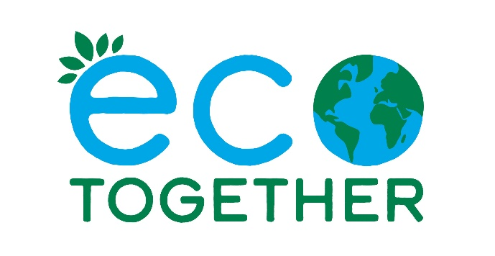

For immediate release: (date)
Contact: (Name, email)

Eco Together group starting in (location)
On the heels of the heatwave and drought, and rising energy costs, the Eco Together project is starting in (location) to help people tackle climate change and save money.
It is a simple project for small groups of friends or neighbours. The group gets together for five structured sessions that cover energy, transport, food and resources.
The groups explore the powers each person has to create change, through lifestyle, community, advocacy and communication. Eco Together provides a handbook developed by environmental professionals to help each person choose activities that suit them best. Anyone can join or form a group, regardless of age, income, or worldview. It works very well with neighbours and existing groups; workplaces, student groups, book clubs or residents associations.
To find out more, please contact: (email)
Local residents (your name?) said (this is why I want to do Eco Together in my area)
Coordinator Sara Grimes said “As a mum of a seven-year-old I worry about the climate, especially after this summer’s drought and wildfires. Now going into the cost-of-living crisis I’m wondering what will happen to food and energy prices. It’s easy to feel helpless. There’s lots we can do though, and Eco Together gives you the space and support to find your own eco; what you can do to save money and the environment in your current life situation. I’ve been in two Eco Together groups, we were all different but we learned lots from each other and made impressive changes. It feels great to have the support of like-minded people. It’s also helped me get round to insulating my house, which will help with the rising energy costs this winter”.
Four successful pilot groups have already been run. Group members took a wide range of actions, from reducing plastic and energy use to contacting their councillors and raising climate change at work. Members reported that it was a non-judgemental and thought-provoking way to look at climate change.
Dr Robin Teoh, a GP, hosted a group: “Getting together some friends and neighbours didn’t take much time at all; then we just followed the programme. With the clear structure and fascinating yet concise information, our get-togethers were enjoyable and productive. Whether new to the ideas or eco-active for years, we all learned, felt supported, made changes for the better and found new friends. We have ongoing plans to help our neighbourhood. All so worthwhile”.
Group member Allen Gilliland said “My wife and I are new to the area and this was a great way to meet like-minded neighbours and learn about local eco resources. We’ve started buying local food and driving less”.
Eco Together is hosted by Transition Bath, a longstanding environmental charity. There will be four Eco Together information sessions at the Bath & North East Somerset Climate and Biodiversity Festival from the 24 September to 2 October. The website is www.ecotogether.info or contact (email)
# # #
