

First Host Notes



**Thanks for your interest in convening an Eco Together group!**

The project has been carefully designed to have a light workload and be simple enough for anyone to run.

The First Host is deliberately intended to *NOT* be the “chair” or “leader” of the group, so that the First Host can participate in the project. The First Host could be described as “convening” – bringing together the group.

**You can convene a group on your own, or jointly with other people you know.**

The First Host does have three special roles which are covered in this document:

1. Getting a group together
2. Running the first session
3. Feeding back on progress

# **Getting a group together**

Eco Together can be run with any small group of around 5-10 people of neighbours, friends and anyone within your community.

## **Gathering a group of friends or people from an interest group**

This should be straightforward – simply ask them, and find a date and venue for the first session. You may need to chat with them to explain the project first. Feel free to do this from your own knowledge, perhaps using the wording in the next paragraph. Contact [hello@ecotogether.info](mailto:ecotogether2030@gmail.com) if you’d like support.

Brevity is key in your introduction. The following uses the wording on the first page of the website, and can work as a ***social media message, or as a verbal introduction***. e.g.:

**Concerned about the environment?**

**Eco Together brings together small groups of neighbours, friends or colleagues for 5 structured sessions.** The group members support each other in making a difference. Using an Info Pack designed to ​bring tangible results and to help build strong support groups, each person selects their own activities.

Group members run the sessions themselves and there are no costs involved.

***There are also some*** [***template emails***](https://docs.google.com/document/d/1RnKgxDAg_tjRdEtGLCkrcDcnevM_3bezYnaA0wp9qI4/edit) ***for you to use to make your follow up easier.***

**Gathering a group of neighbours**

It might be very easy to get your neighbours involved if you already know them, you can just ask them if they want to join the group and start with the first session if so.

If you don’t know your neighbours, or need a few more involved, feel free to use the table in Appendix 1 to work backwards to a date. **Be kind to yourself if you are busy – allow yourself plenty of time 😊**

**Getting the word out**

**Templates:** You can use our [templates](https://docs.google.com/document/d/1RnKgxDAg_tjRdEtGLCkrcDcnevM_3bezYnaA0wp9qI4/edit) of flyers, posters, presentation slides and social media to get the word out. These are very basic and low tech to be easily editable, and you may be able to do far better ones! Feel free to copy and paste the Eco Together logo onto your materials.

**Budget:** We don’t have much budget for the project, but if printing costs are a barrier, please let us know: [hello@ecotogether.info](mailto:ecotogether2030@gmail.com).

**Useful tools**

* **Emailing**: If you don’t want to use your personal email address on your promotional material, you can create a new free email account ([for example Gmail](https://support.google.com/mail/answer/56256?hl=en)) to manage correspondence on the project.
* **Choosing a date:** You could use a simple scheduler site such as [Doodle](https://doodle.com/poll/y8f8sqaapq57kgcw) which, whilst it now has a lot of popup ads, gathers people’s date choices and can save a lot of time. Similarly, WhatsApp has this function. *A note of caution* – people who are less comfortable with computers may need the dates emailed or written to them rather than using Doodle.

**Types of promotion**

1. **Posters** can be downloaded from the First Host page, printed and displayed in windows and waterproof holders around the neighbourhood.
2. **Leaflets** can be posted through your neighbours’ doors. We suggest 50-100. If you don’t get enough people, you could try another round. Please keep track of how many flyers you used and how many people got in touch to say they were interested so you can let us know in the feedback form.
3. **Digital:** Consider a message on a street or local social media group or through a residents’ association.
4. **Print:** To go beyond your own street, consider local magazines or a Parish newsletter.
5. **Intro session:** You may be able to move straight to the first session if people seem fairly committed. Or if people need more info, you could run an intro session. Contact [hello@ecotogether.info](mailto:ecotogether2030@gmail.com) if you’d like support with this, or feel free to organise how you see fit.

**Creating further groups**

In an ideal world, a couple of people from each Eco Together group would go on to be First Host for another group – if they started with neighbours, convening a group of friends or an interest group and vice versa.

This way, the project would organically expand geographically as in the diagram below. However, people’s lives are fuller than ever. It is brilliant if any group member simply completes the first 5 sessions.

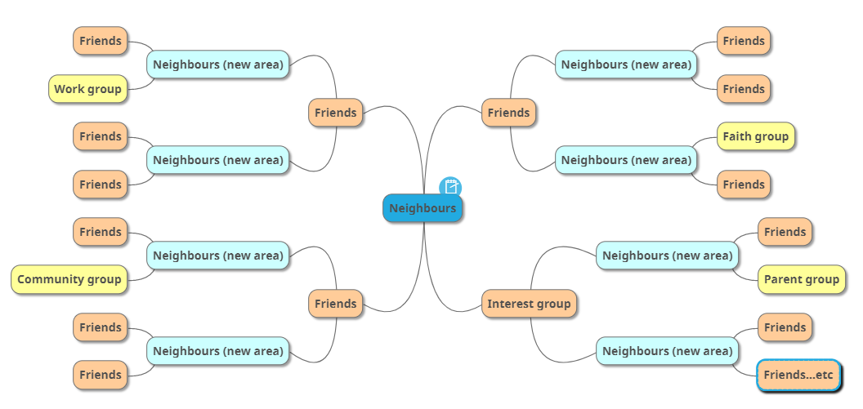

# **Running the first session**

**The First Host does not need any special knowledge**. The sessions have been designed to be simple enough to “run themselves” through the Activity Sheet, with just a little input from the host to keep things moving.

**During the first session, could you please ask your group to fill in a** [**short feedback**](https://docs.google.com/forms/d/e/1FAIpQLSeEdjp90jcMroCCmtJLS9XZg2YhRmPXYuAJFFWOfyhXRWnH2Q/viewform?vc=0&c=0&w=1&flr=0) **to help up measure the impact of the program.**

# There are a few things you can do to help that first session go smoothly:

* **A few days before the session,** consider reminding people that in order for the session to run more smoothly, there is some really interesting reading and thinking to do, in the Info Pack.
* **Make sure people can access the** [**Info Pack**](https://www.ecotogether.info/_files/ugd/e53f2c_d398af6a69574cbab0bdc60eba3f195a.pdf) **and** [**Activity Sheets**](https://www.ecotogether.info/_files/ugd/e53f2c_c05e0f00c9544595a8acd15edd03e7ed.docx?dn=ECO%20TOGETHER%20ACTIVITY%20SHEETS_FINAL%20V2.3%20(20).docx)**.** People can either print them or view them online, but some may find either a challenge and may not speak up unless asked.
* **In each session** there is a series of exercises. Give the group a minute or two to think and to note down their response, then take it in turns for each person to speak.
* The **Guidelines** agreed in the first session should help you – people agree to take it in turns to speak so everyone gets a chance, and to not interrupt or make comment until everyone has done this. The whole group should help with this, but people may need to be reminded – it’s interesting stuff so it’s easy to get off track.
* Consider appointing **a timekeeper** to help you stick to the schedule.
* Enjoy! You are just helping it to run smoothly, giving everyone their fair chance to speak.

**During the last session , could you please ask your group to fill in a short survey to help up measure the impact of the program** [**End of the project feedback**](https://docs.google.com/forms/d/e/1FAIpQLSdQ07ZKbIfIzydvJX-zG9Xf03Y23q5-KcYlSG2xzhY_ZrGHUQ/viewform?vc=0&c=0&w=1&flr=0)

# **Feeding back on progress**

Your feedback is like gold-dust as we think about the next steps of the project. We don’t want to overload you with paperwork, but we’d be very grateful if you could fill out a [feedback form](https://forms.gle/pPbUTBqL2LhYcRHu7) and submit it to us at the end. Please be very honest so we can evolve the project. We will circulate the monitoring survey prior to the end of the project.

**APPENDIX 1: PROMOTION PLAN**

|  |  |  |  |
| --- | --- | --- | --- |
| NEIGHBOUR PROMOTION  TIMELINE | How many weeks will it take you? | Date to start | Possible tasks – you choose. Each could take around an evening to complete. |
| Prepare promotion |  |  | * Edit posters, leaflets * Get leaflets printed * Decide which streets you’ll leaflet in the first round and which to leaflet if you don’t get enough (around 100 houses per round) * Edit social media/ email message * Contact local residents’ group to see about email message * Contact community magazine to see about a mention * Set up a new email address if you don’t want to give out your personal email |
| Release promotion |  |  | * Leaflets out * Posters up * Social media and emails sent |
| Do more promotion if you don’t get enough people |  |  |  |
| Talk to people and agree date for first session |  |  |  |
| Approximate date of first session |  |  |  |